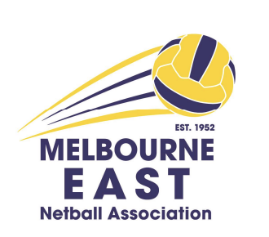
Melbourne East Netball Association
Registration No: A0011747L
ABN 54 201 268 575
Photography & Filming Policy
Correspondence to: PO Box 613, Heathmont 3135
Email: admin@menanetball.com.au
Phone 0411 691 888

CONSENT AS CONDITION OF COMPETITION ENTRY EXEMPTION REQUEST FORM

MENA may wish to record images and video footage of participants during this competition for promotional and training/development purposes. These images and video footage may be used in mediums including publications and promotional material, and broadcast, print and electronic media.

MENA agrees not to use any photo in a manner that may be deemed adverse or defamatory to the person(s) involved and it will not use the photo for any commercial gain. The photo will remain the property of MENA and any personal details regarding this photo will be kept confidential and will not be used for any purpose other than related to this photo

During this competition parents and family of players may wish to record images of their family members participating for personal use only. Where possible, such requests will be authorised and subject to certain conditions, noting that on public land, this is not enforceable. Clubs may also wish to take images or film for player training or promotional use.

It is a condition of entry into the MENA competition that participants may be subject to photography/filming as described above, and that consent is provided as part of the entry process.

** Under special circumstances an exemption may be granted – the team/individual needs to state, in writing, the reason an exemption is being sought

Reason exemption sought

Team member name:

Club: Team name:

Signed
(Player or guardian if player under 18 years)

Print Name: Date:

